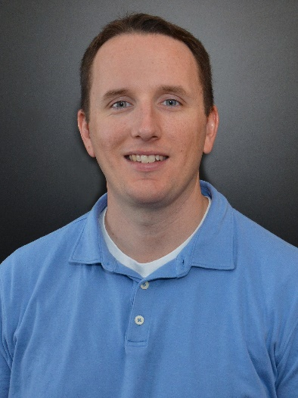 | Dr. Jake Smithwick, FMP, SFP  University of North Carolina at Charlotte  Simplar

BIO
Dr. Jake Smithwick is the go-to resource for any facility professional who wants to elevate their team’s capabilities through O&M performance benchmarking and talent development. Together with his colleagues at Simplar, Jake has assisted hundreds of owners improve performance outcomes across thousands of projects. His industry experience also includes field inspection of nearly 2,000 roofing systems across the United States, and six years in the US Air Force Reserve (emergency management / civil engineering squadron). He is a professor in the William States Lee College of Engineering at the University of North Carolina in Charlotte.

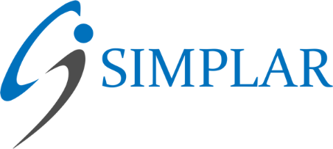
ABOUT SIMPLAR
Simplar is a collaborative team of faculty and researchers from universities across the United States who specialize in facility organizational assessment, performance measurement and analytics, process improvement, and advanced procurement delivery systems. Learn more at www.simplar.com.

